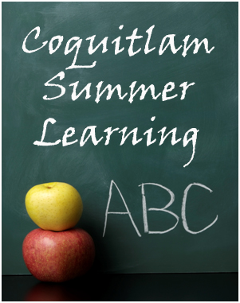
SUMMER LEARNING 2013
Registration Start Dates

Grade 10 Courses: May 7th
Grade 11/12 Courses: May 9th

You must have an account with our online system BEFORE registering for courses.

Please visit our website and create/update your account NOW.

Visit www.summerlearningcoquitlam.ca for more information.

